Scenario 11: You want to get an alert if unauthorized access attempts (eg, blocked port 22) happened.
VPC flow logs >cloudwatch logs > cloudwatch Alarm > amazon SNS
we will receive an email alert whenever someone tries to SSH (port 22) into your EC2 instance and gets REJECTED by Security Groups or NACLs.
Step1 : enable vpc flow logs to cloudwatch logs
- We have already done it
Step 2: go to CloudWatch logs Insights and run a query to detect
SSH REJECTS.
fields @timestamp, @ScrAddr, @dstAddr, @dstPort,action
|filter dstPort=22 and action = "REJECT"
| sort @timestamp desc
| limit 10000
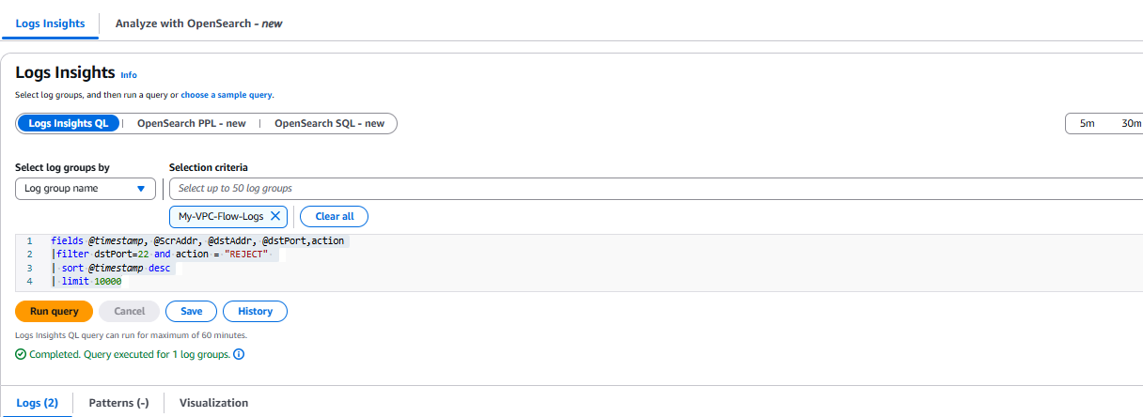

Step 3: Create a CloudWatch Metric Filter
1. Go to CloudWatch → Log groups
2. Choose the log group tied to your VPC Flow Logs
3. Click “Create Metric Filter”
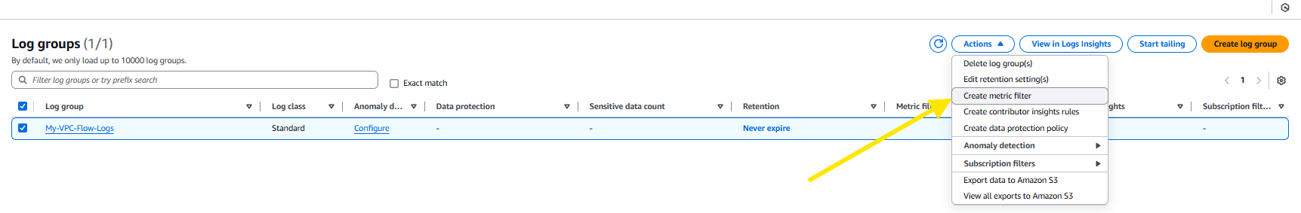

4. Use this pattern:
{ $.dstPort = 22 && $.action = "REJECT" }
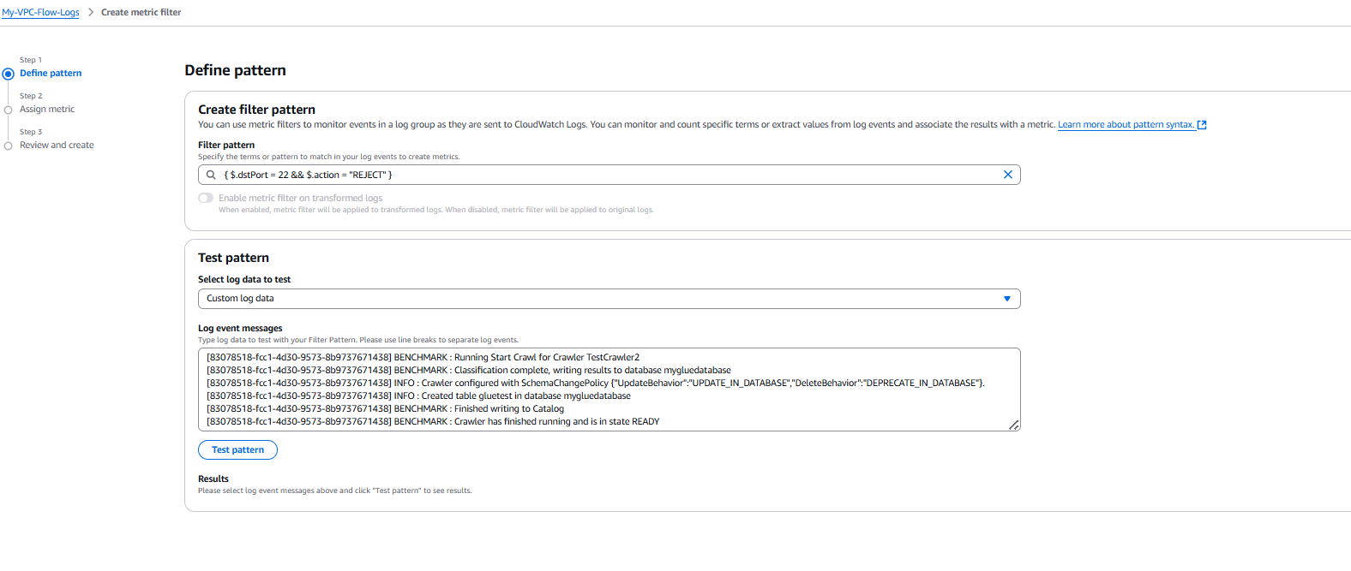
5.Define:
Metric namespace: `UnauthorizedAccess`
Metric name: `SSHRejects`
Metric value: `1`
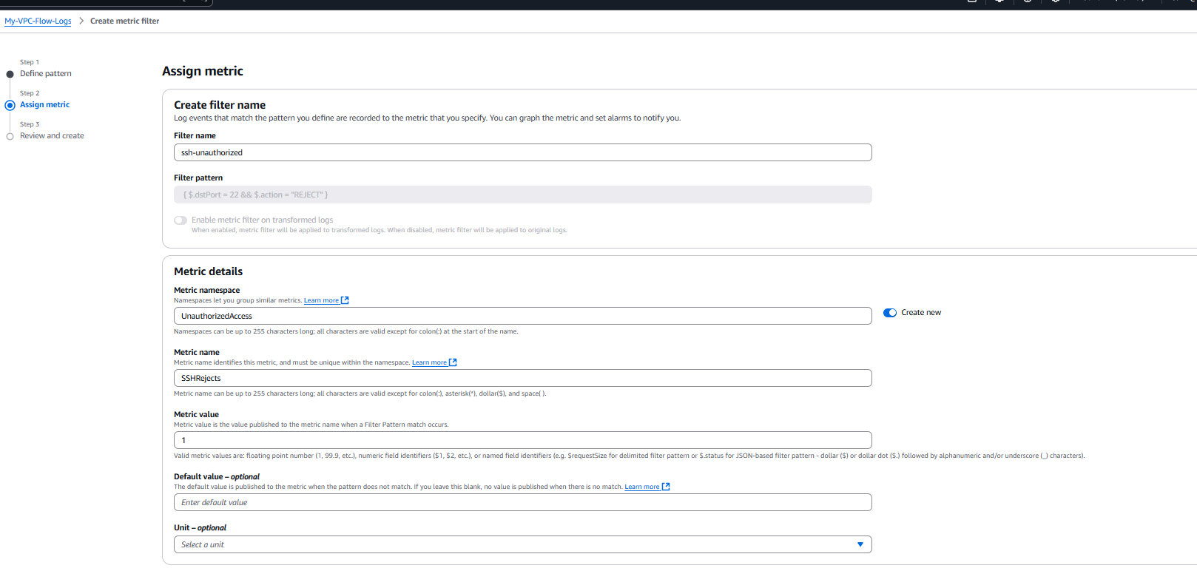
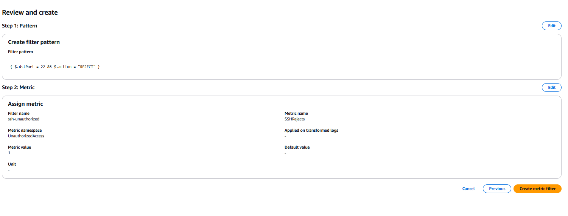
Step 4: Create CloudWatch Alarm
- Go to CloudWatch → Alarms → Create Alarm
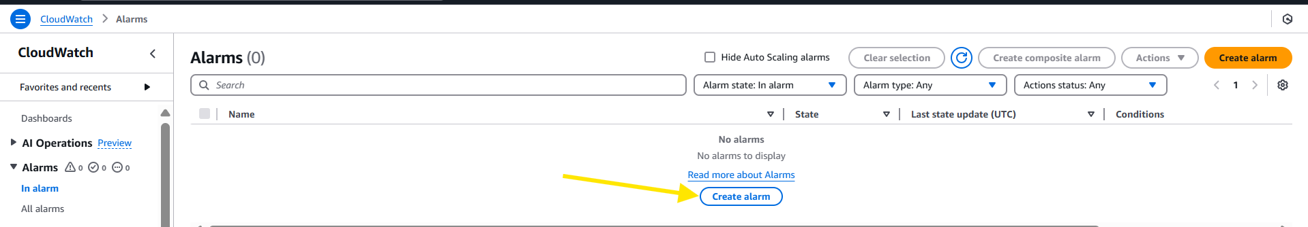
- Use the metric from Step 3

3. Set condition:
Threshold: `>= 1`
Period: `5 minutes` (or your choice)
4. Add SNS topic to get notified (email, Lambda, etc.)
Step 5: Create SNS Topic
1. Go to SNS → Topics
2. Create topic like `UnauthorizedSSH`
3. Subscribe with your email address
4. Confirm the subscription

